67

Community-Building Activities for Staff Members
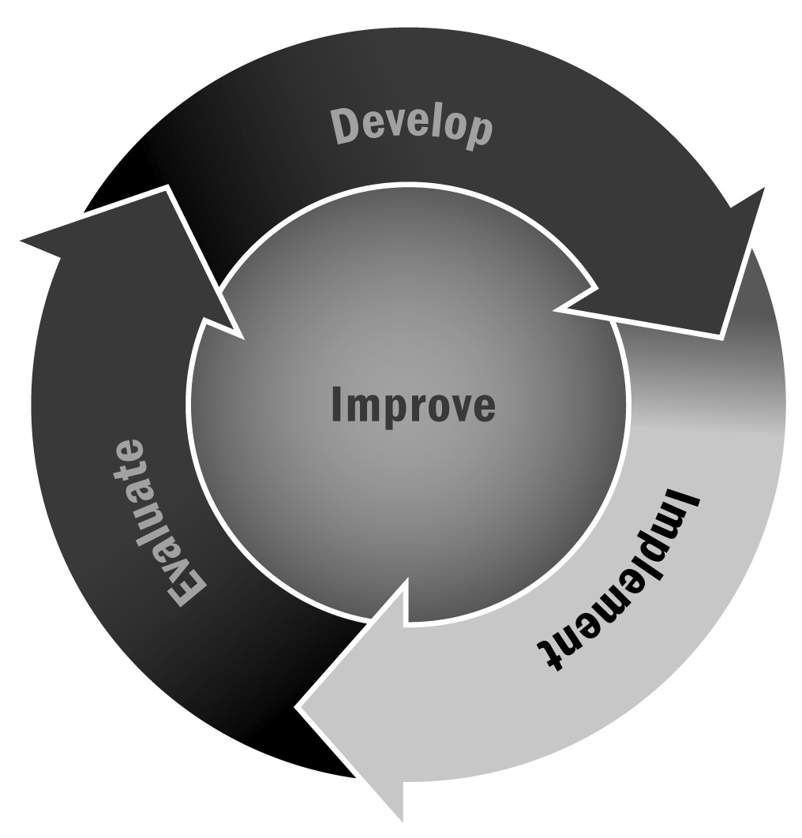
In Chapter 4, you learned that it is important to put practices in place that will strengthen the relationships among staff members in your program. This not only ensures that they get along with each other but also builds a support system that ultimately strengthens the daily operations of the program.
Directions: The following activities can be used during staff meetings, get-togethers, and other times that the staff members come together as a group to get to know each other and build a stronger sense of community in your program. As the community grows, solicit ideas from staff members and allow them to organize and lead activities.
- “Getting to know you” questions. You can either add a “and why?” to the end of your question or you can instruct everyone not to explain their answer so that follow-up conversations can occur after the activity is over. Sample questions may include:
- If you could have any super power, what would it be?
- What is your favorite meal?
- If you could be any animal what would it be?
- Name one thing you love about yourself.
- Describe your perfect day.
- Who would you invite to your last meal? (The table only seats six.)
- Name one person during your school-age years who had a big influence on you.
- Silent puzzles/problem solving
- Charades (with topical themes)
- Line up according to last name or birthday without talking
- Everyone has a piece of a picture; put it together without any words
- Status update
- Tweet of the day: Explain your day in 140 characters or less and share with the group.
- Write a quick status update that explains your day.
- P.I.E.S.: Write down how you feel Physically, Intellectually, Emotionally, and Spiritually and share with the group.
- Strangers no more: Sit next to someone you don’t know, don’t say anything to them, write down how you feel today and how your partner (the person next to you) is feeling (without asking them). Write down whether they were born in an urban/rural/suburban area, how many siblings they have, their favorite thing about their job, and so on. Introduce them to the group. Then the person shares what the person got right, if anything, and shares missing information.
- Each person writes down a question he or she wants answered on a piece of paper. Next, have each person crumple up his or her piece of paper into a ball and throw it to someone else. Take turns answering the questions. Go for as many rounds as time permits.
- Staff members should split into pairs and find three things that they have in common. Encourage pairs to find “uncommon commonalities”—that is, things that are not obvious. For example, a pair might discover that they both love the same pop singer or that they have a shared interest in painting. Pairs can then share what they learned with the larger group.
- “Rose and a thorn” at the end of the day. Everyone shares one positive thing that happened and one thing that could have gone better.
- At the beginning of an official meeting or training, allow time for silent reflection and focusing. While this is an independent activity, creating an atmosphere where your staff members can be quiet and contemplative with each other is important. This will also allow your staff members to fully engage during the meeting.

